Customers associated with Multiple addresses. ( 3 Customers associated with 5 Addresses)
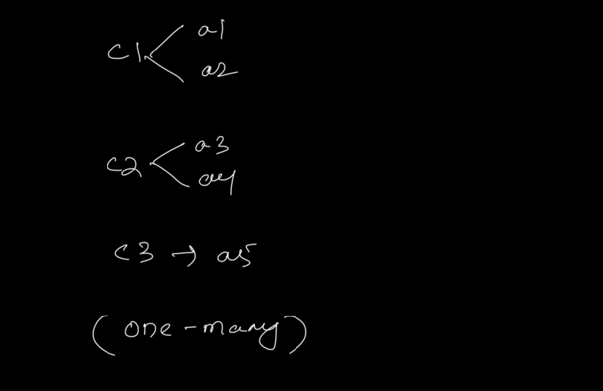
One customer mapped to Many Customers.
Let’s say we need to get all customers with its addresses.
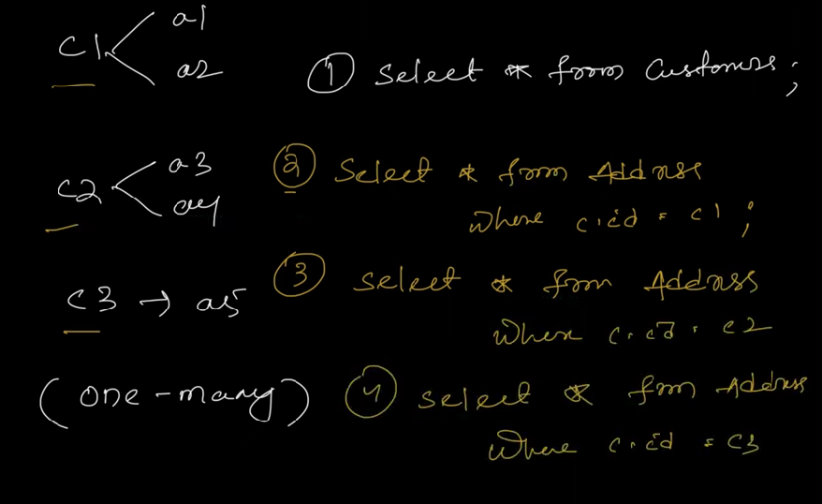
So, to fetch all customers and addresses we need to use 3 Queries for address and 1 Query for Customer.
Which will downgrade your application performance for sure.
To load all the customers and it’s associated addresses. Instead of hitting DB 4 (n+1) times, we can hit DB once to fetch all the data using another approach.
What is N+1 Problem?
Why it is called N+1 Problem?
What is Problem here?
What to do to resolve this N+1 Problem ?Approach/Solution.
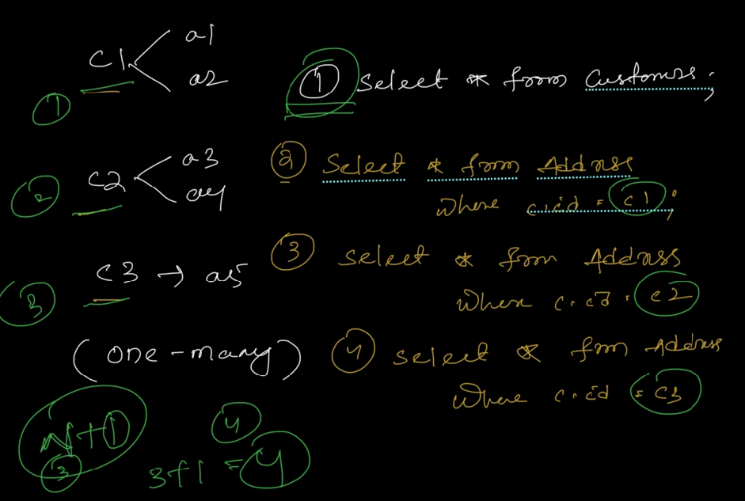
In real time, hitting DB multiple times, will downgrade the application performance.
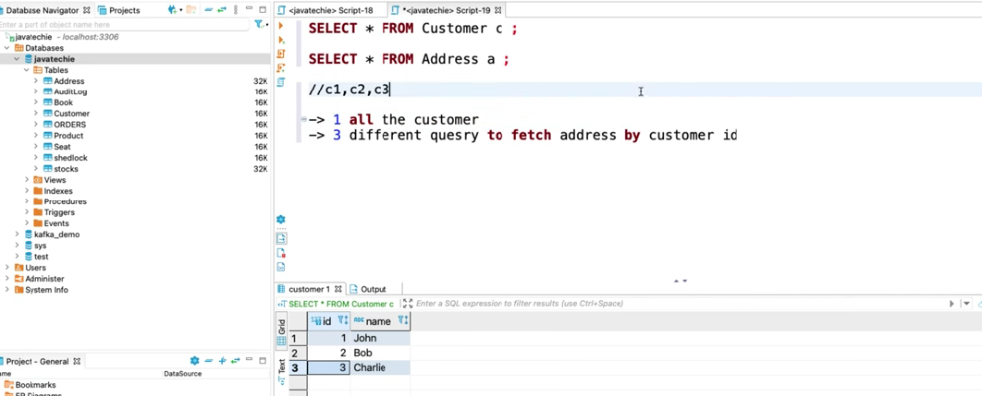
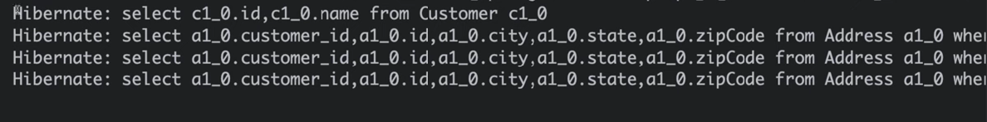
For this to avoid.
we have to override findAll() repository method with EntityGraph annotation, we’ll tell to JPA while loading the Customers, load the addresses aswell.
@EntityGraph(attributePath=”addresses”)
After this
(Explain EntityGraph Annotation, what it does and what is attributePath , explain what this annotation does internally, how it is shrinking the DB hits from N+1 to 1 hit. What does it do Internally (Join and Fetch)
If we don’t want to go with EntityGraph, and wanna write own implementation also we can go ahead and write the method in repository class – custom method.
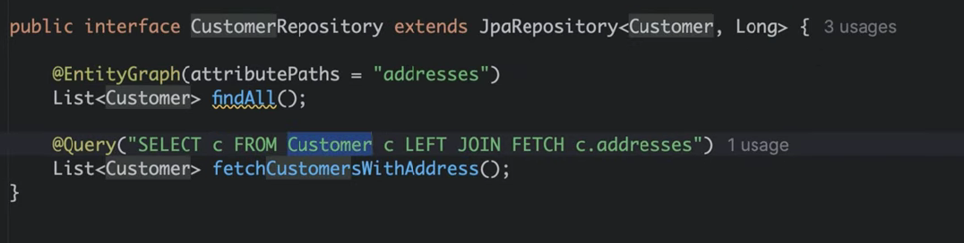
Service class.
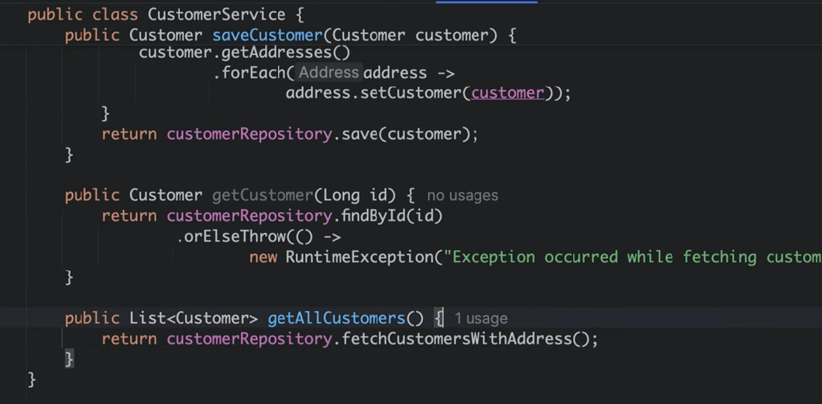
Now, There is no N+1 Problem.
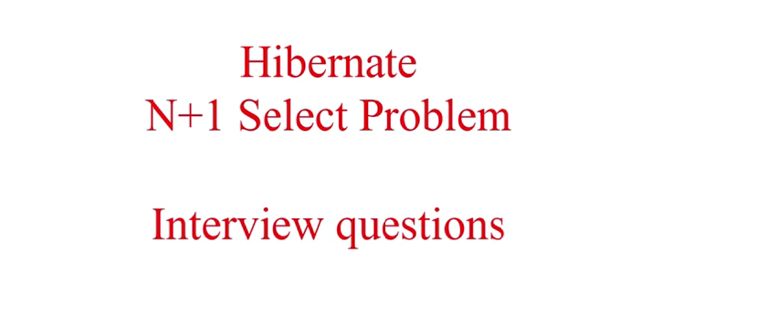
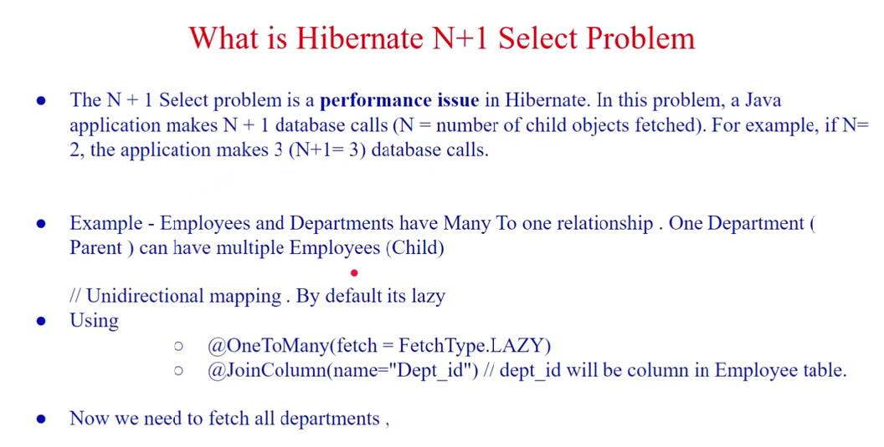
Ex: One Department can have multiple Employees
Department Entity Has OneToMany relationship with Employee.
And it is LazyLoaded, until it is not used ListOf Employees in Department entity is not fetched
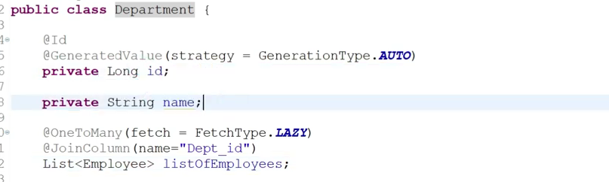

Controller calling all Departments
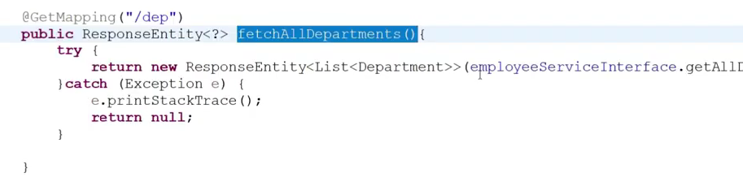
Service
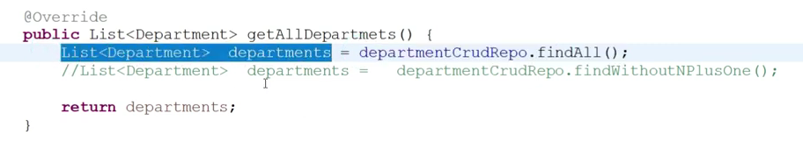
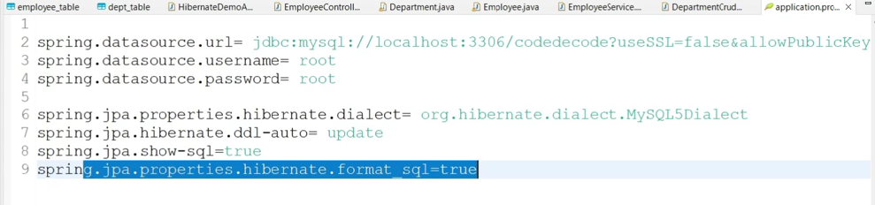
When we hit this controller, then this will call service and it fetches all the departments, and for all departments it fetches all employees N+1 Queries hit ( N+1 Problem)
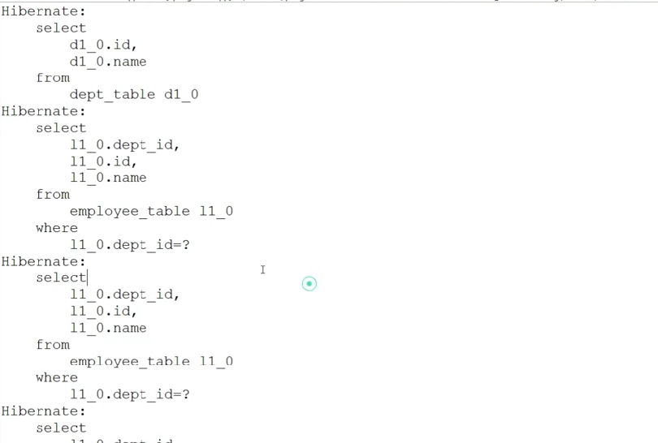
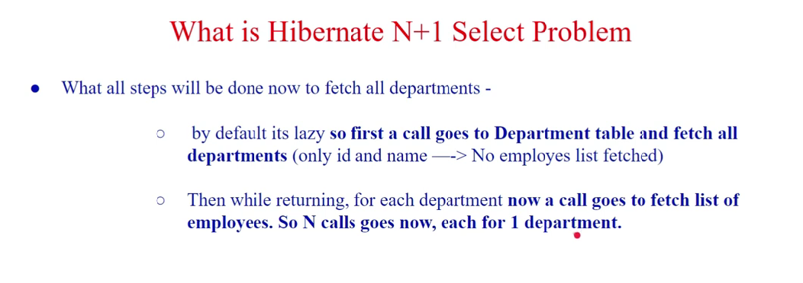

N+1 Problem Solution
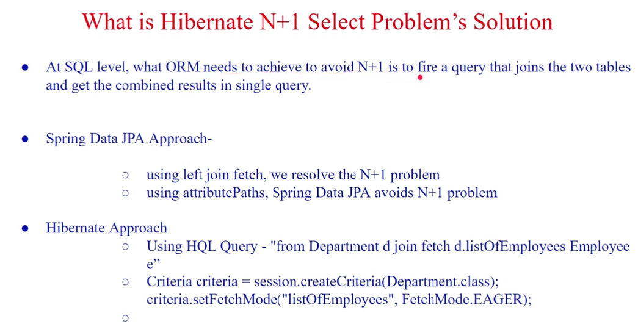
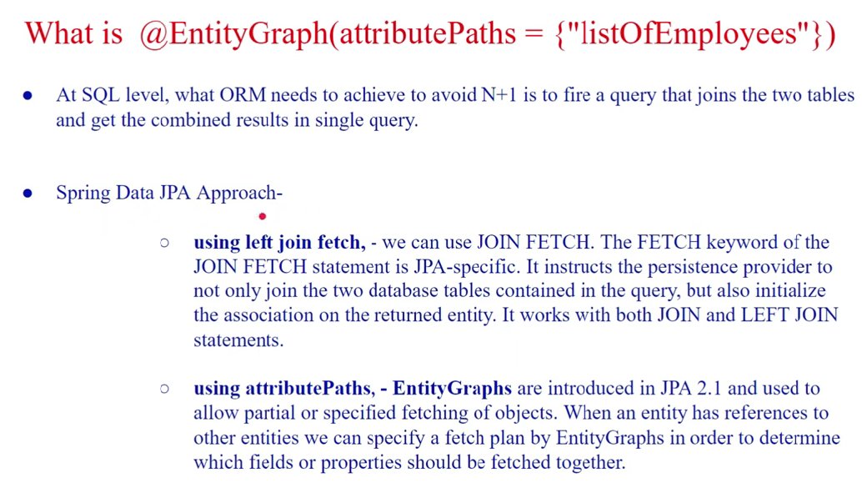
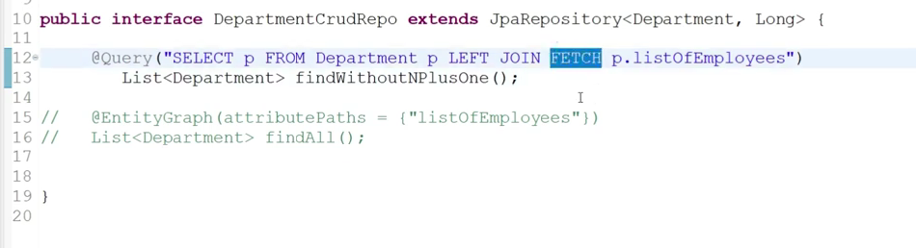
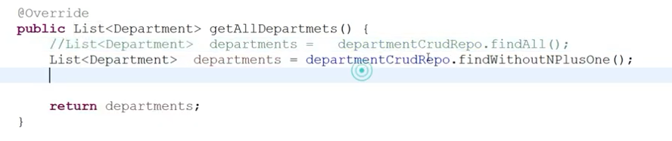
Now, only one query executes
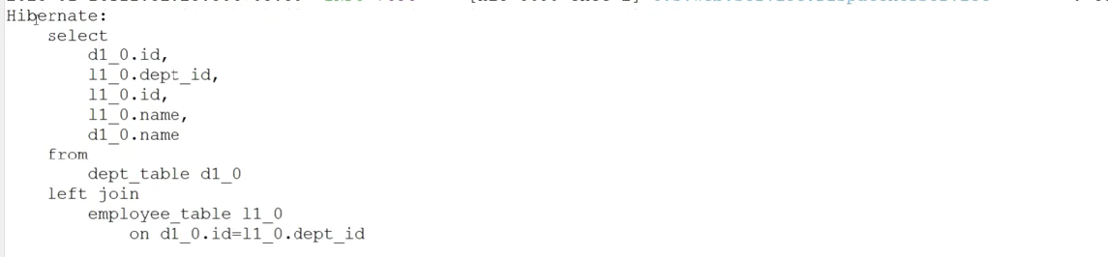

Spring Data JPA – Approach using Entity Graph
